

(ISO 9001:2015 Certified), Accredited with ‘A’ Grade by NAAC

08258 - 281039 – 281263, Fax: 08258 – 281265



**Department of Computer Science and Engineering**

B.E. CSE Program Accredited by NBA, New Delhi from 1-7-2018 to 30-6-2021

**MOBILE APPLICATION DEVELOPMENT MINI PROJECT SYNOPSIS** -**19CSE42**

**TITLE : QUORA CLONE**

**PROJECT IS DONE UNDER THE GUIDANCE OF DR.ANISHA.P.R**

**TEAM MEMBERS:**

**NAME :** Arsh Imtiyaz Assadi **NAME:** Adithya Holla K

**USN:** 4NM19CS032 **USN:** 4NM19CS007

[**EMAIL :**4nm19cs032@nmamit.in](mailto::4nm19cs032@nmamit.in) [**EMAIL :**4nm19cs007@nmamit.in](mailto::4nm19cs007@nmamit.in)

**SIGNATURE : SIGNATURE :**

i



(ISO 9001:2015 Certified), Accredited with ‘A’ Grade by NAAC

08258 - 281039 – 281263, Fax: 08258 – 281265



**Department of Computer Science and**

**Engineering**

B.E. CSE Program Accredited by NBA, New Delhi from 1-7-2018 to 30-6-

2021

**TABLE OF CONTENTS**

**PROBLEM STATEMENT .....................................................................................................** 3

**OBJECTIVES…………………………………………………………………………………………**3

**TECHNICAL DETAILS………………………………………………………………………………**4

**DESCRIPTION.................................................................................................................…..**4

**FUNCTIONALITIES..............................................................................................................** 5

**CONCLUSION ......................................................................................................................** 5

iii

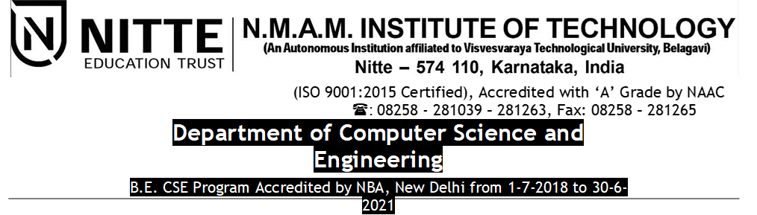

**PROBLEM STATEMENT :**

Now days the people are afraid to ask the answer for the question with others because they think that how the other people would react to them. The one who ask the questions he may think whether he is able to get answer for his questions . To avoid this problem our Questioner App help the them to post their questions in the app and get their answer or solutions to their questions.

**OBJECTIVES:**

* This app allow the the user to post the questions and answer then in corresponding topic.
* This app allow the user to answer the questions.
* Logging in with their credentials and profile picture.
* Liking the post and commenting.

Dept. of CSE, NMAMIT Page 4

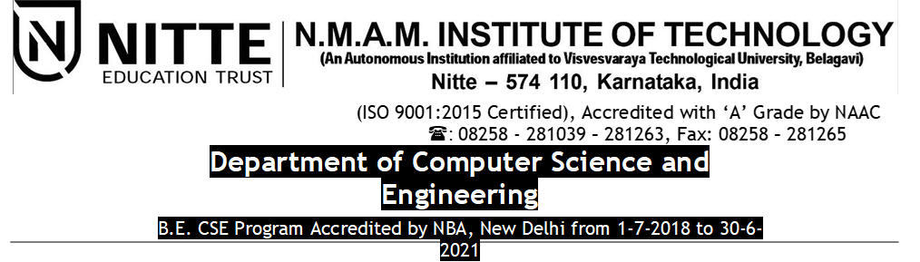

**TECHNICAL DETAILS:**

**SOFTWARE CONFIGURATIONS:**

* Operating System: Windows 10
* Workspace: Android Studio
* Android XML: Page layout using Android XML
* Android: Project has been developed on Android Platform
* Java: Coe will be written using Java

**HARDWARE CONFIGURATIONS:**

* RAM: 8 GB
* Hard disk: MINIMUM 200 GB
* Processor: Intel i5 Processor

**DESCRIPTION**

This app enables users post their own questions in the corresponding topics and also answer questions if they can. They can view their posted questions and their posted answers. The users will be able to like the questions and answers posted

Dept. of CSE, NMAMIT Page 6

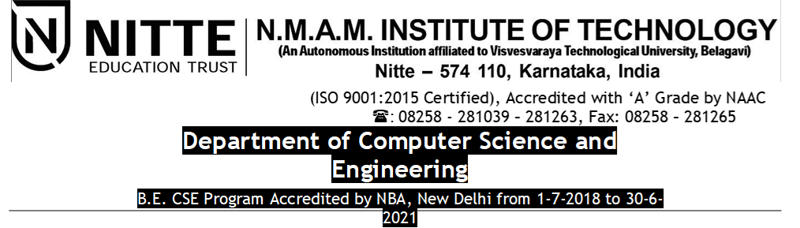

**FUNCTIONALITIES:**

**1. Ask The Question :**

To help the user to ask the question or post the question. If the user had doubt in any of the topic.

**2. Answer The Question :**

This app allow the user to post the answer for the questions which has been posted by other users.

**3. View The Posted Questions And Answers:**

This allow to view the questions and answers which had been posted by the users.

**4. Like And Comment On Questions Posted:**

User can like the answer or question posted by others and also they can comment on this .

**5. Login With The User Credentials And Profile Pic :**

User can login this app by login through their credentials and profile pic

Dept. of CSE, NMAMIT Page 6

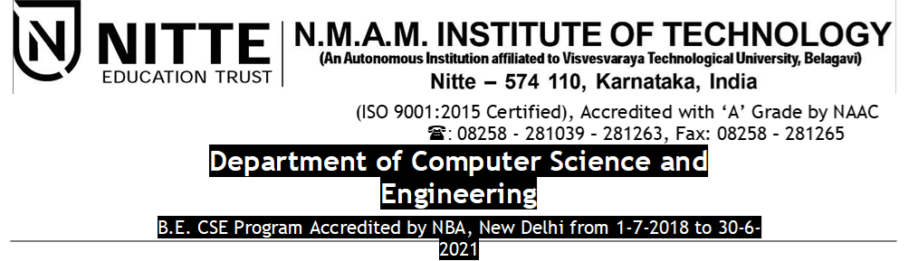

**CONCLUSION :**

The following app enables users who have doubts and questions to post them in the app and people who have similar questions to view them and post the answers. This enables people to clear doubts and ask questions they were too afraid to ask.